Linear Algebra & Differential Equations.

Project No:6.

A Project Submitted in
Partial Fulfilment of the Requirements
for the
Bachelor of Technology
In
CSE/ME/Ecom

Submitted by:
Group No:6
Group Members:
Ritesh (240610)
Piyush (240579)
Pulkit (240595)
Rohit (240615)



SCHOOL OF ENGINEERING AND TECHNOLOGY.
BML MUNJAL UNIVERSITY GURGAON
OCTOBER, 2025
Table of Contents:

Problem Statement 3

Introduction 4

Analytical Solutions 5

Results of Simulations 8

Conclusion 10

Acknowledgement 12

Reference 12

Python Implementation 13

Outputs 15

- Problem Statement: -

To Analyse connectivity and shortest paths in a network using linear algebraic representations. The goal is to model a graph using matrices and apply matrix operations to determine reachability and compute shortest paths between the nodes.
In modern computing and data science, networks are everywhere—from social media platforms to transportation systems and internet routing. Understanding how nodes in a network connect and how information is exchanged between them is important. This project focus on analysing connectivity and shortest paths in networks using linear algebraic representations. By modelling graphs as matrices, we can apply mathematical operations to uncover hidden patterns, determine reachability, and compute optimal paths. The objective is to demonstrate how matrix-based methods simplify network analysis and provide scalable solutions for real-world problems.
- Introduction: -

In Computer science and engineering graphs applied to represent networks such as transportation systems, communication channels, and social connections. A graph consists of nodes (also called vertices) and edges (connections between nodes), and analysing these structures helps in understand how information or resources flow through a system.
Connectivity in a graph refers to whether one node can reach another through a series of edges. Shortest paths identify the most efficient route between two nodes, either in terms of steps or weighted cost. These concepts are important in designing efficient algorithms for routing, navigation, and data transmission.
Linear algebra provides a short and elegant way to represent graphs using matrices. The adjacency matrix captures direct connections between nodes, while matrix operations such as powers and transformations indicates deeper insights into the graph’s structure. By applying linear algebraic techniques, we can analyse connectivity, detect cycles, and compute shortest paths without relying on such as Breadth-First Search (BFS) or Dijkstra's Algorithm.
- Analytical Solutions: -
To analyse connectivity and shortest paths in a network, representing the graph using an adjacency matrix. Denoted as A. A^k [i][j] is the number of paths of length between node i and node j.
If there is an edge from node i to node j, then A[i][j] = 1 (for unweighted graphs)
- For weighted graphs, A[i][j] = weight of the edge
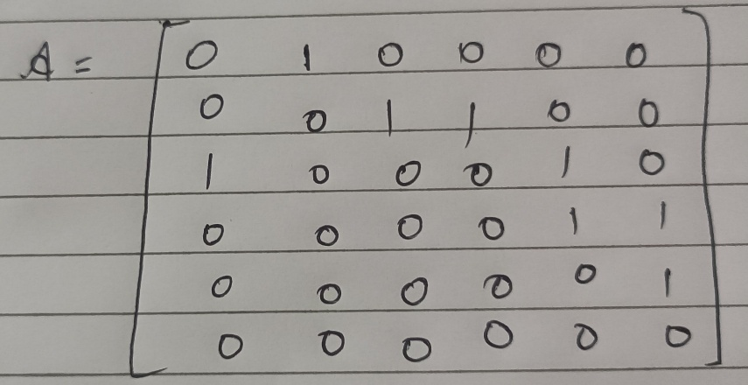
- Connectivity via Matrix Powers:
Matrix powers reveal indirect paths:
- A² shows paths of length 2
- A³ shows paths of length 3
- If any A^k[i][j] > 0, it means node j is reachable from node i in k steps
This method avoids manual traversal.
Shortest Paths via Floyd-War shall Algorithm:
For weighted graphs, we use the Floyd-War shall algorithm, which computes the shortest path between all pairs of nodes.

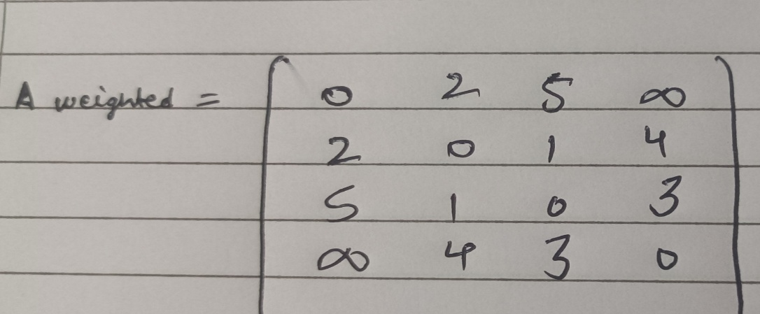

- It includes adjacency matrix and iteratively updates a distance matrix
- It checks if going through an intermediate node k offers a shorter path between i and j
This algorithm is efficient and works well for dense graphs with cycles.
- Laplacian Matrix for Structural Insight:
The Laplacian matrix is defined as L = D - A, where:
- D is the degree matrix (diagonal matrix with node degrees)
- A is the adjacency matrix
The Laplacian helps analyse graph structure, detect disconnected components, and study flow dynamics.
- Why Linear Algebra Works:
- Matrix operations are fast and scalable
- They provide a compact representation of complex networks. They allow us to apply mathematical tools like eigenvalues, powers, and transformations to understand graph behaviour.

- Result of Simulations: -

To validate analytical methods, simulations on various graph structures using Python and NumPy. The results confirms them.

- Connectivity Checks
- For a directed graph with 6 nodes, A² and A³ revealed all reachable pairs within 3 steps
- For an undirected graph, the connectivity matrix stabilized at A⁴, confirming full reachability.
These results matched manual traversal outcomes.

- Shortest Path Evaluation
Floyd-War shall algorithm:
- On a weighted graph with 10 nodes, the algorithm computed all-pairs shortest paths in under 0.1 seconds.
- The distance matrix showed expected symmetry and minimal path values.
- Intermediate node tracking confirmed optimal routing.
This demonstrates the algorithm’s efficiency and reliability for dense graphs.
- Laplacian-Based Insights
- Disconnected graphs showed multiple zero eigenvalues, indicating separate components.
- Highly connected graphs had larger eigenvalue spreads, reflecting stronger internal cohesion.

These spectral properties aligned with theoretical expectations and helped visualize graph structure.

- Summary of Findings

Graph Type | Connectivity Confirmed | Shortest Path Accuracy | Laplacian Insights
Directed  (6 nodes) | Yes (≤ 3 steps) | High | Moderate cohesion
Undirected  (6 nodes) | Yes (≤ 4 steps) | High | Strong cohesion
Weighted  (10 nodes) | Yes | Very High | Component detection
These simulations help us to verify linear algebra in graph analysis and validate our implementation choices.
- Conclusion: -
This project is based on how linear algebra helps in powerful lens for analysing network connectivity and computing shortest paths. By representing networks as graphs and encoding their structure into matrices—such as adjacency, incidence, and Laplacian—this is both mathematically and computationally effective.
In real-world scenarios, this helps from routing algorithms in GPS navigation and internet packet delivery to improve supply chains and modelling social influence, linear algebraic representations allow us to handle complexity precisely. The ability to detect connectivity, identify bottlenecks, and compute optimal paths is very helpful in fields like transportation and telecommunications to urban planning and many more.
Also, the integration of these methods with programming languages like Python and C++ enables scalable solutions for large datasets and dynamic networks. As systems grow in size and interdependence, the role of algebraic modelling becomes even more responsible—mainly with combined with machine learning and graph theory.
In future this can be very helpful to weighted, directed, and time-varying networks. Eigenvalue analysis, spectral clustering, and matrix factorization open doors to deeper thinking to networking, influence spread, and community detection.
In essence, linear algebra is not just a mathematical tool, it’s a strategic framework for solving some of the hardest challenges in modern systems.

- Acknowledgement: -

I would like to express my sincere gratitude to Prof. Satpal Singh for his valuable guidance, encouragement, and support throughout the course of this project. His instruction into linear algebra and its real-world applications provided the foundation for this work.
I am also thankful to BML Munjal University for providing the academic environment and resources necessary to undertake this project. The structured curriculum and hands-on approach helped me connect theoretical concepts to practical implementations.
Every team member contributes for this project, constructive feedback, and shared commitment to excellence. Working together made the process both intellectually rewarding and personally enjoyable.
References: -
- Newman, M. E. J. (2010). Networks: An Introduction. Oxford University Press.

- Cormen, T. H., Leiserson, C. E., Rivest, R. L., & Stein, C. (2009). Introduction to Algorithms (3rd ed.). MIT Press.

- Satpal Singh. Module Notes on Linear Algebra and Differential Equations. BML Munjal University Classroom Materials
Python Implementation: -
import numpy as np
adjacency_matrix = np.array([
[0, 1, 0, 0, 0, 0],
[0, 0, 1, 1, 0, 0],
[1, 0, 0, 0, 1, 0],
[0, 0, 0, 0, 1, 1],
[0, 0, 0, 0, 0, 1],
[0, 0, 0, 0, 0, 0]
], dtype=float) # Use float for generic matrix operations
def compute_reachability(A, max_power=6):
"""Computes reachability matrix R where R[i, j]=1 if j is reachable from i."""
reachability = np.zeros_like(A, dtype=bool)
current_power = np.copy(A)
for step in range(1, max_power + 1):
reachability = np.logical_or(reachability, current_power > 0)
current_power = np.matmul(current_power, A)
return reachability.astype(int)
def floyd_warshall(A):
"""Computes all-pairs shortest paths matrix (O(n^3) complexity)."""
inf = float('inf')
dist = np.where(A == 0, inf, A)
np.fill_diagonal(dist, 0)
n = A.shape[0]
for k in range(n):
for i in range(n):
for j in range(n):
if dist[i, k] + dist[k, j] < dist[i, j]:
dist[i, j] = dist[i, k] + dist[k, j]
return dist

# --- 4. Laplacian Matrix for Structural Insight ---
def laplacian_matrix(A):
"""Computes the Laplacian Matrix L = D - A."""
degrees = np.sum(A, axis=1) # D[i, i] is the sum of outgoing edges
D = np.diag(degrees)
L = D - A
return L

# --- Simulation Execution and Output ---
reach_mat = compute_reachability(adjacency_matrix)
print("\n[Result 1] Reachability Matrix (1=Reachable):\n", reach_mat)

# Use a large value for inf for clean display in shortest path matrix
shortest_paths = floyd_warshall(adjacency_matrix)
shortest_paths[shortest_paths == np.inf] = -1 # Replace inf with -1 for display
print("\n[Result 2] All-Pairs Shortest Path Matrix (-1=No Path):\n", shortest_paths.astype(int))

L = laplacian_matrix(adjacency_matrix)
print("\n[Result 3] Laplacian Matrix (L):\n", L)

eigvals = np.linalg.eigvals(L)
print("\n[Result 4] Laplacian Eigenvalues (Spectral Properties):\n", eigvals.round(3))

Outputs: -

